Napkin Drawing Feedback from James

Q1 Drawings

You could maybe add a trendline to the scatter plots

Bar graphs look good

Box plots look good

Q2 Drawings

Education vs Insured – I assume the x axis will show include labels for the levels of education. If not, that can be added.

The horizontal bar charts look good

I like that the vertical bar charts use percentages of respondents, instead of raw figures.

Q3 Drawings

I personally don’t understand the IPR metric, but this should be good as long as it is covered in the presentation.

Top 5 Least Insured States – Unless I am understanding this plot wrong, I would suggest considering the order in which theses are displayed on the graph (ex. The state with the highest % of uninsured could be #1, the lowest % uninsured could be #5, then display them descending). \*NOTE: I looked at this one before realizing there is also a Top 5 Most Insured States and I think I see the thought process in how both of these are displayed, so I suppose take it or leave it with my initial feedback

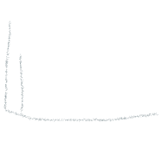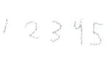

Q4 Drawings

Interested to see the outcome of this statistic.

Overall, I think these drawings are all good and it looks like they are telling a cohesive story about insurance and health costs. From the visualization ideas, I would think group 2 is on the right track. Can’t wait to see the finished product